### WEEKLY PLAN/LESSON PLAN

*LTS form 104*

Lecturer’s Name: ___Jian Paulo Aquino____ Course/Year and Sec: BSIT 1-4

Tutee #: 2

Week 1: DATE: __03/05/23__

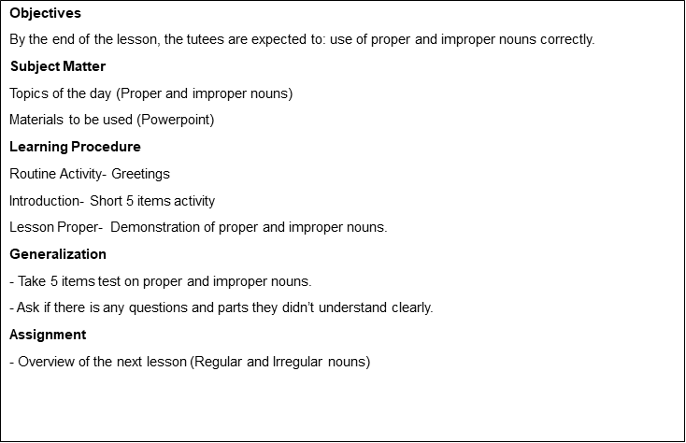

Week 2: DATE: __03/12/23_

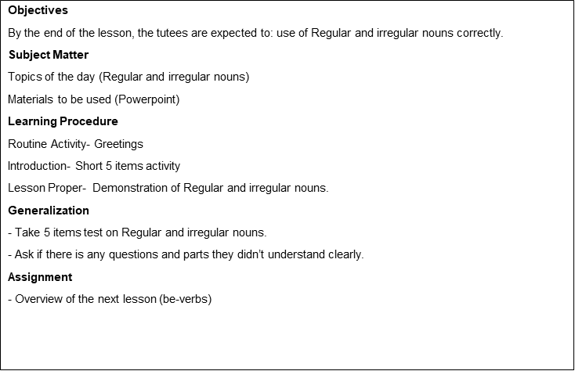

Week 3: DATE: __03/19/23_

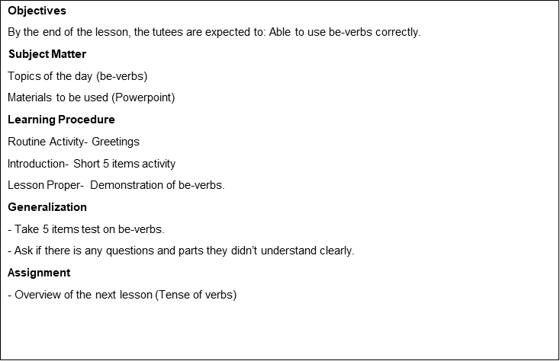

Week 4: DATE: __03/26/23_

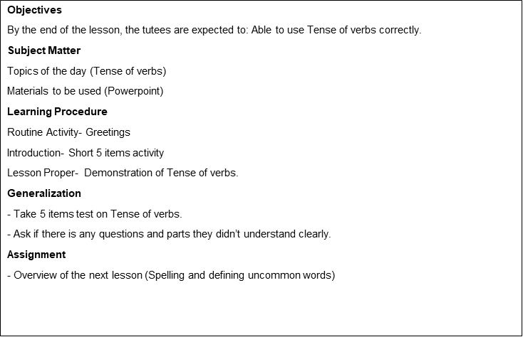

Week 5: DATE: __04/09/23_

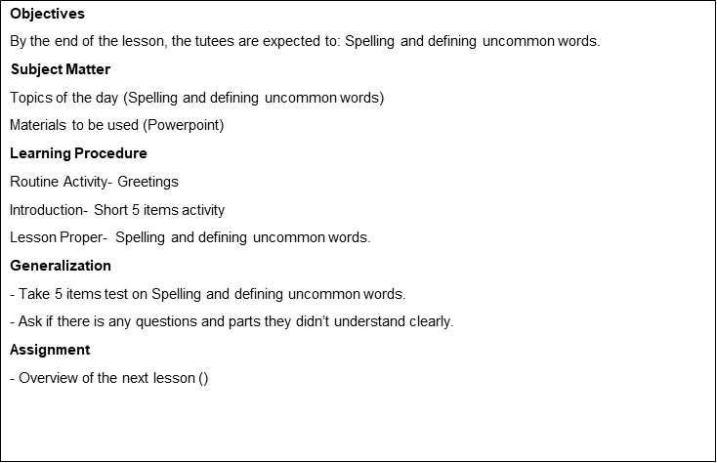

Week 6: DATE: __04/16/23_

|  |
| --- |
| **Objectives**  By the end of the lesson, the tutees are expected to: pronounce uncommon words correctly  **Subject Matter**  Topics of the day (pronouncing uncommon words correctly)  Materials used (Powepoint)  **Learning Procedure**  Routine Activity – Greetings  Introduction – Short 5 items activity  Lesson proper - pronouncing uncommon words correctly  **Generalization**  Take 5 items post-test in pronouncing uncommon words correctly  Ask if there is any question and parts they didn’t understand clearly  **Assignment**  Overview of the next lesson |

Week 7: DATE: __04/23/23_

|  |
| --- |
| **Objectives**  By the end of the lesson, the tutees are expected to: use pronouns correctly  **Subject Matter**  Topics of the day (Pronouns)  Materials used (Powepoint)  **Learning Procedure**  Routine Activity – Greetings  Introduction – Short 5 items activity  Lesson proper - Pronouns  **Generalization**  Take 5 items post-test in pronouns  Ask if there is any question and parts they didn’t understand clearly  **Assignment**  Overview of the next lesson |

Week 8: DATE: __04/30/23_

|  |
| --- |
| **Objectives**  By the end of the lesson, the tutees are expected to: use subject and predicate correctly  **Subject Matter**  Topics of the day (Subject and predicate)  Materials used (Powepoint)  **Learning Procedure**  Routine Activity – Greetings  Introduction – Short 5 items activity  Lesson proper - Subject and predicate  **Generalization**  Take 5 items post-test in subject and predicate  Ask if there is any question and parts they didn’t understand clearly  **Assignment**  Overview of the next lesson |

Week 9: DATE: __05/7/23_

|  |
| --- |
| **Objectives**  By the end of the lesson, the tutees are expected to: use adjectives correctly  **Subject Matter**  Topics of the day (Adjectives)  Materials used (Powepoint)  **Learning Procedure**  Routine Activity – Greetings  Introduction – Short 5 items activity  Lesson proper - adjectives  **Generalization**  Take 5 items post-test in adjectives  Ask if there is any question and parts they didn’t understand clearly  **Assignment**  Overview of the next lesson |

Week 10: DATE: __05/14/23_

|  |
| --- |
| **Objectives**  By the end of the lesson, the tutees are expected to: use adverbs correctly  **Subject Matter**  Topics of the day (adverbs)  Materials used (Powepoint)  **Learning Procedure**  Routine Activity – Greetings  Introduction – Short 5 items activity  Lesson proper - adverbs  **Generalization**  Take 5 items post-test in adverbs  Ask if there is any question and parts they didn’t understand clearly  **Assignment**  Overview of the next lesson |

Week 11: DATE: __05/21/23_

|  |
| --- |
| **Objectives**  By the end of the lesson, the tutees are expected to: write a simple story  **Subject Matter**  Topics of the day (Writing)  Materials used (Powepoint)  **Learning Procedure**  Routine Activity – Greetings  Introduction to lesson  Lesson proper - Writing  **Generalization**  Writing a simple short story  Ask if there is any question and parts they didn’t understand clearly  **Assignment**  Overview of the next lesson |

Week 12: DATE: __05/28/23_

|  |
| --- |
| **Objectives**  By the end of the lesson, the tutees are expected to:  Read a simple english story with correct pronunciation.  **Subject Matter**  Topics of the day (Reading)  Materials used (Powepoint)  **Learning Procedure**  Routine Activity – Greetings  Introduction to lesson  Lesson proper – Reading a simple story.  **Generalization**  Read a simple english story with correct pronunciation.  Ask if there is any question and parts they didn’t understand clearly  **Assignment**  Overview of the next lesson |

Week 13: DATE: __06/4/23_

|  |
| --- |
| **Objectives**  By the end of the lesson, the tutees are expected to:  Read and analyze a simple story, knowing the plot.  **Subject Matter**  Topics of the day (Reading and analyzing)  Materials used (Powepoint)  **Learning Procedure**  Routine Activity – Greetings  Introduction to lesson  Lesson proper - Read and analyze a simple story, knowing the plot.  **Generalization**  Read and analyze a simple story, knowing the plot.  Ask if there is any question and parts they didn’t understand clearly  **Assignment**  Overview of the next lesson |